**Application**

**-Group 13**

Our Digital Assistant for student regarding library is a web-based application that allows students to manage their library books in a better way by providing them with bunch of handy features. This online cloud-based management system also provides easy ways for librarians to create and store their library collections which can be viewed by students.

Following the link takes the user to the first page of our web application lets name it “main page”. The main page comes with 3 options each for different kind of users they are student, librarian, and the administrator. Let’s see the application for each user, starting with student.

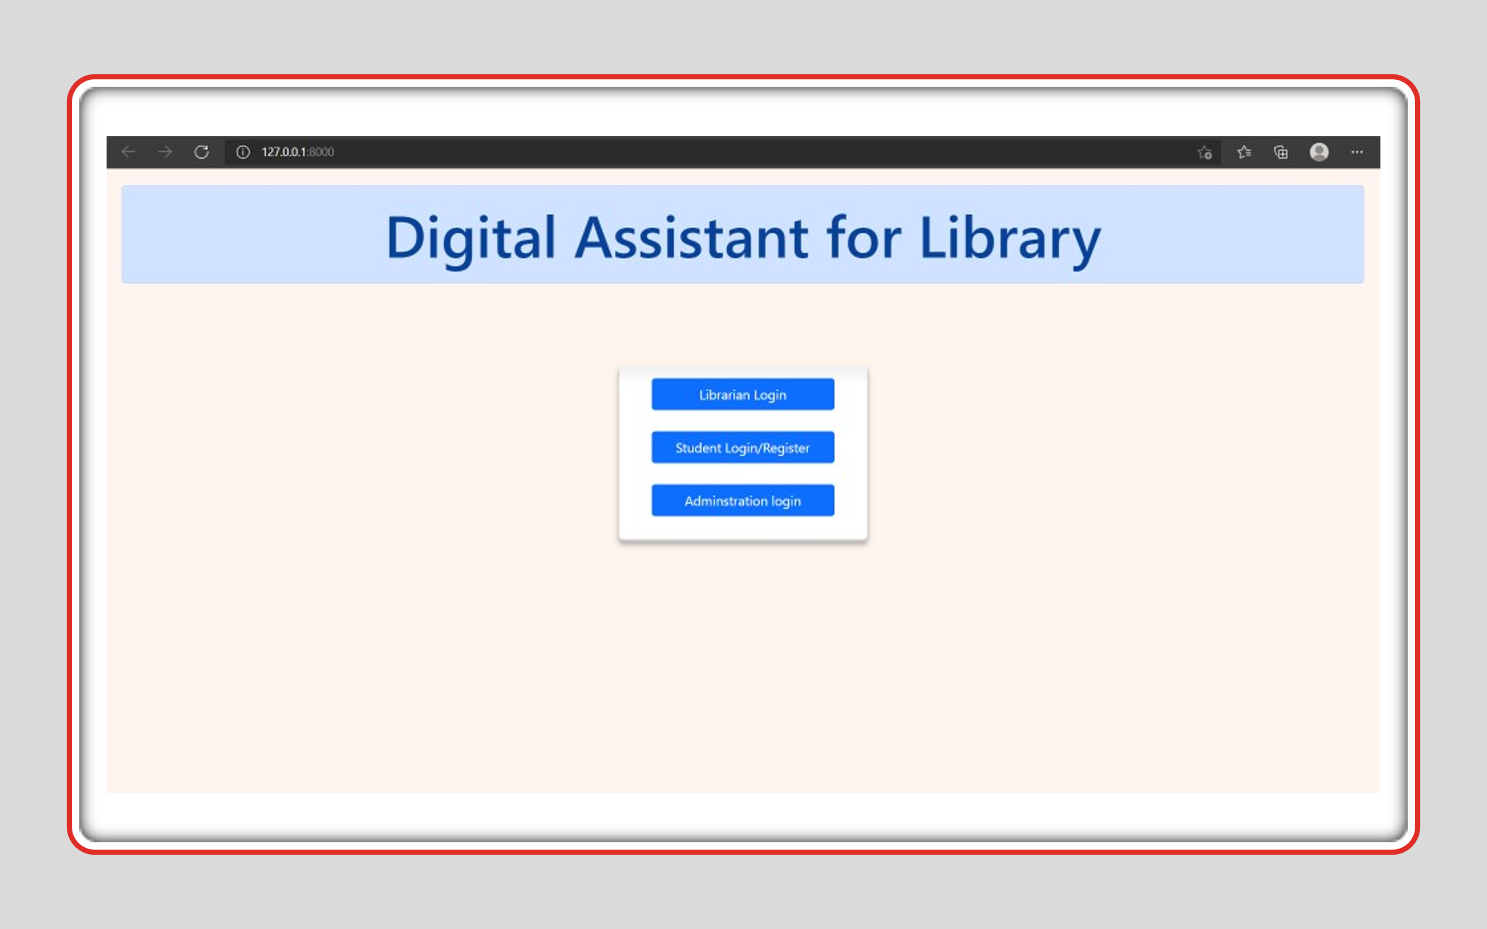

Student

* The first step student must do is select the option named “Student Login/Register”.



* If the Student is already registered, he can login with his credentials. If the student is new, he should choose the register option and can send request for registration to librarian.

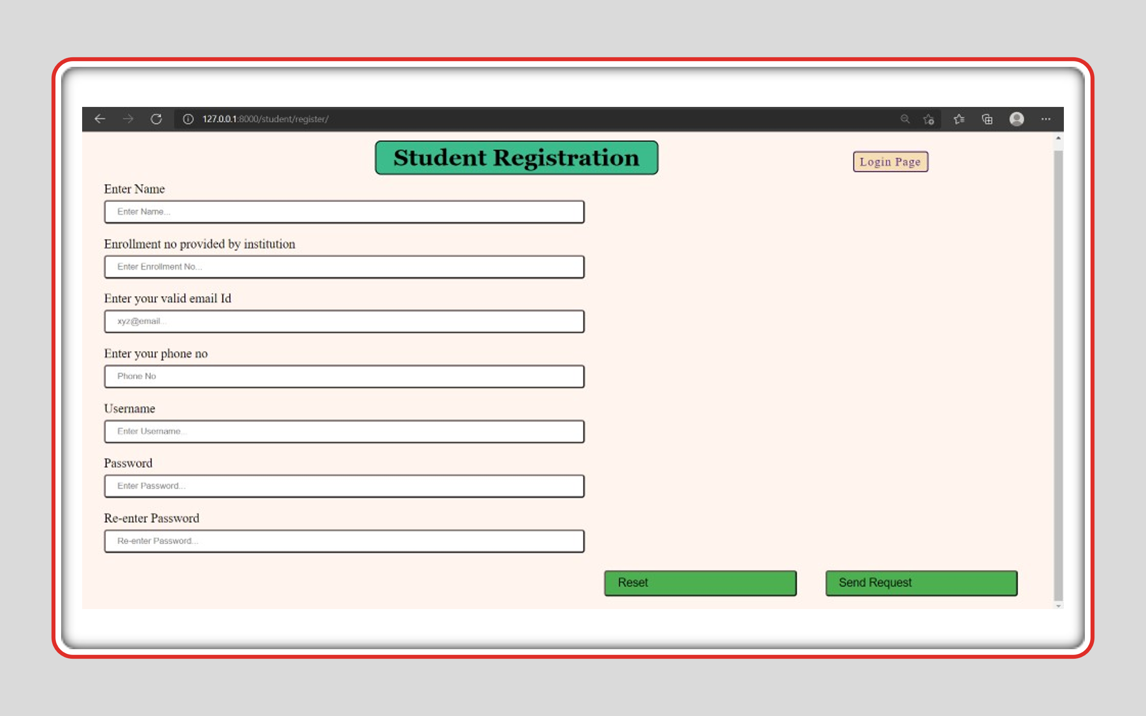

* By logging in we reach to the page as shown below. with following options:

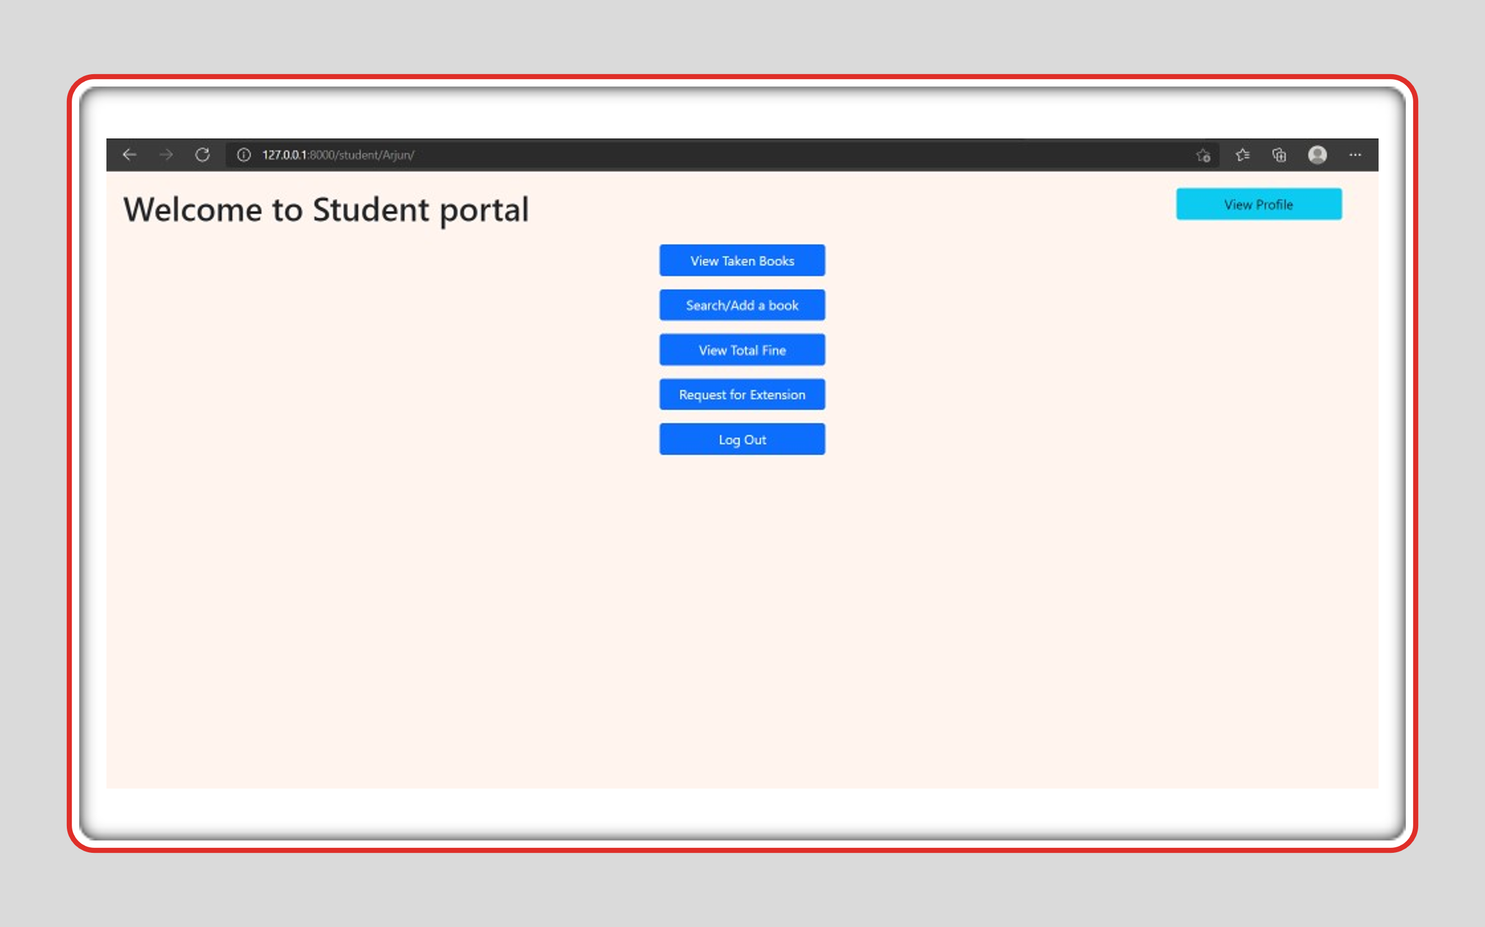

Let’s discuss the application of each of the above-mentioned options

**View Profile**

It displays the student’s personal information



It containsa feature to update his profile information

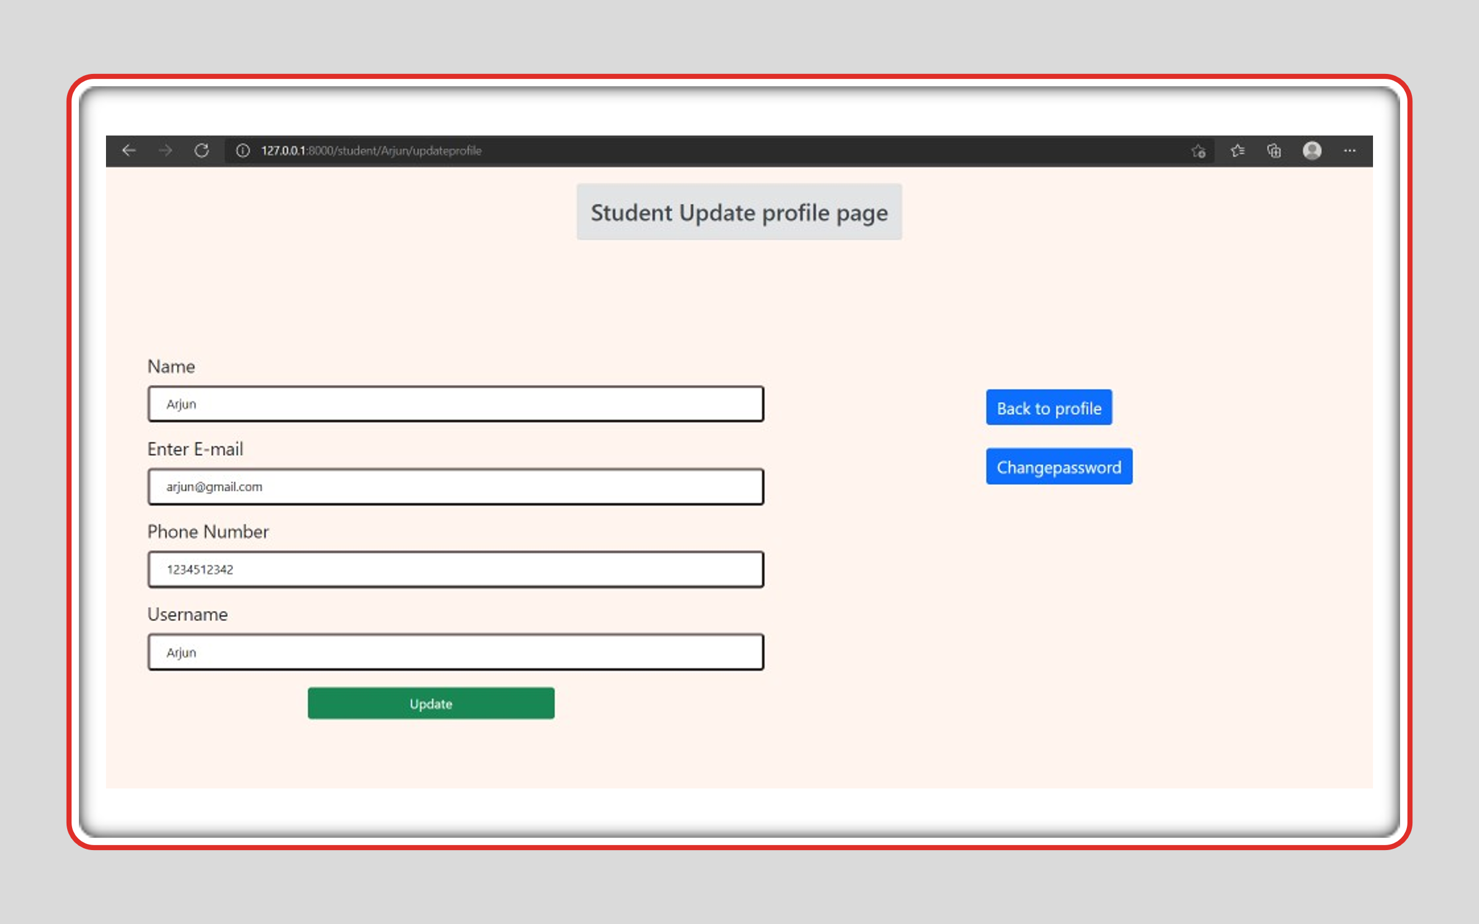

It also includes changing password

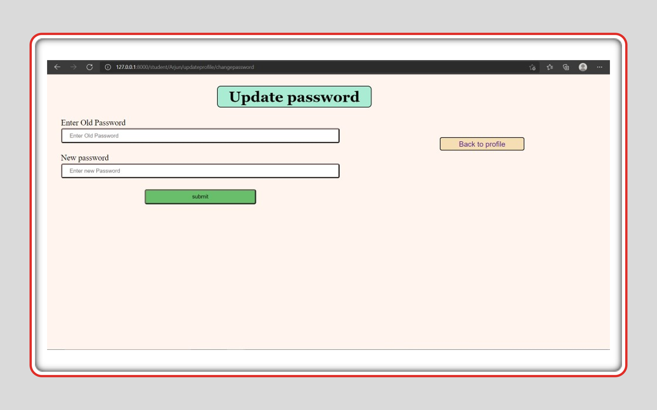

**View Taken Books**

Here, we can see list of Taken books and list of reserved books

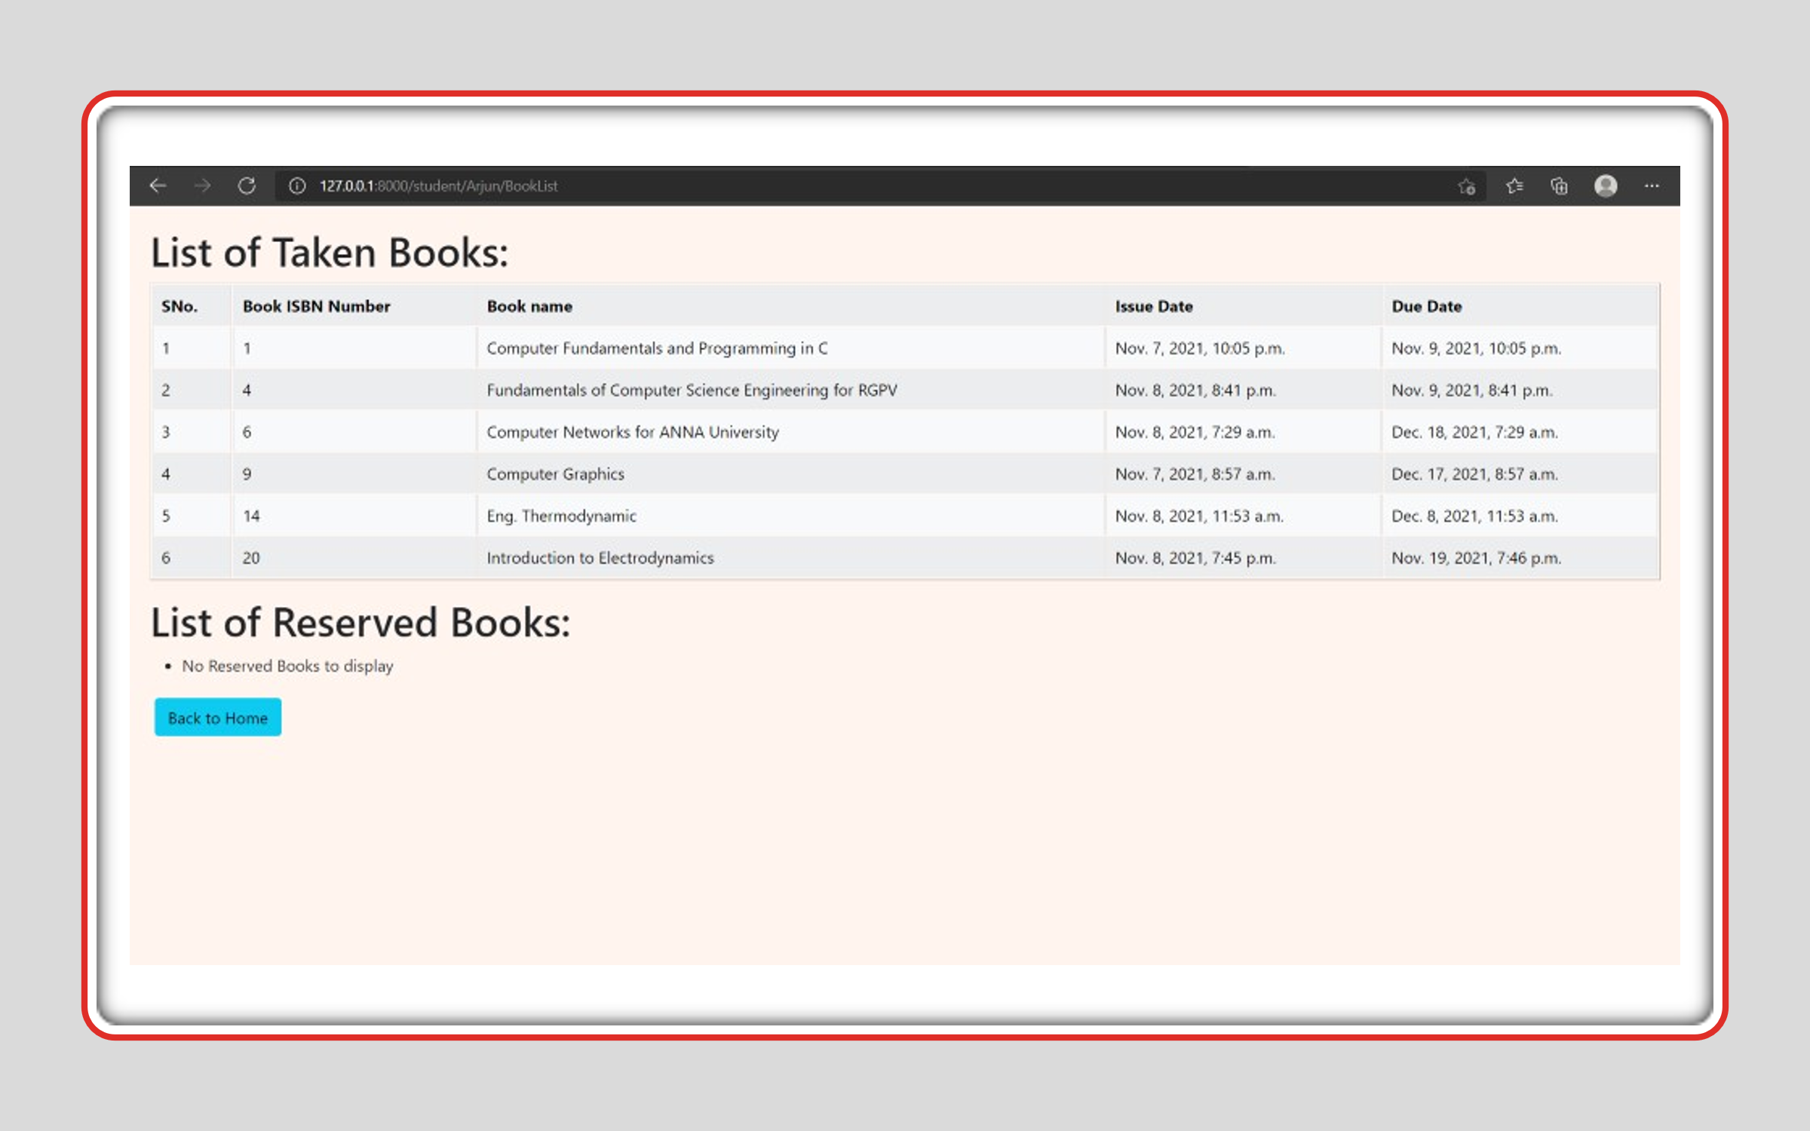

**Search/Add a book**

First, here we can select a book form the list and then click on search

As a response to the search, we get all the information of the selected book as shown in below pic

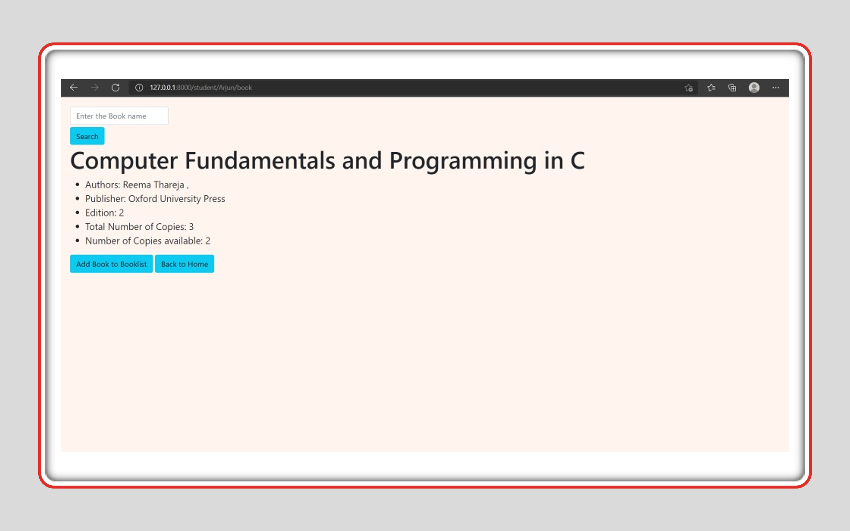

It has the feature to ‘Add book to booklist’ if a copy of the selected book is available.

If the book is not available at present but will be available in 3 days, we get an option to reserve the book in advance.

**View Total Fine**

A table containing books taken (and overdue), due date, overdue days and fine of each book is displayed in tabular way. It also displays the total overdue fine.

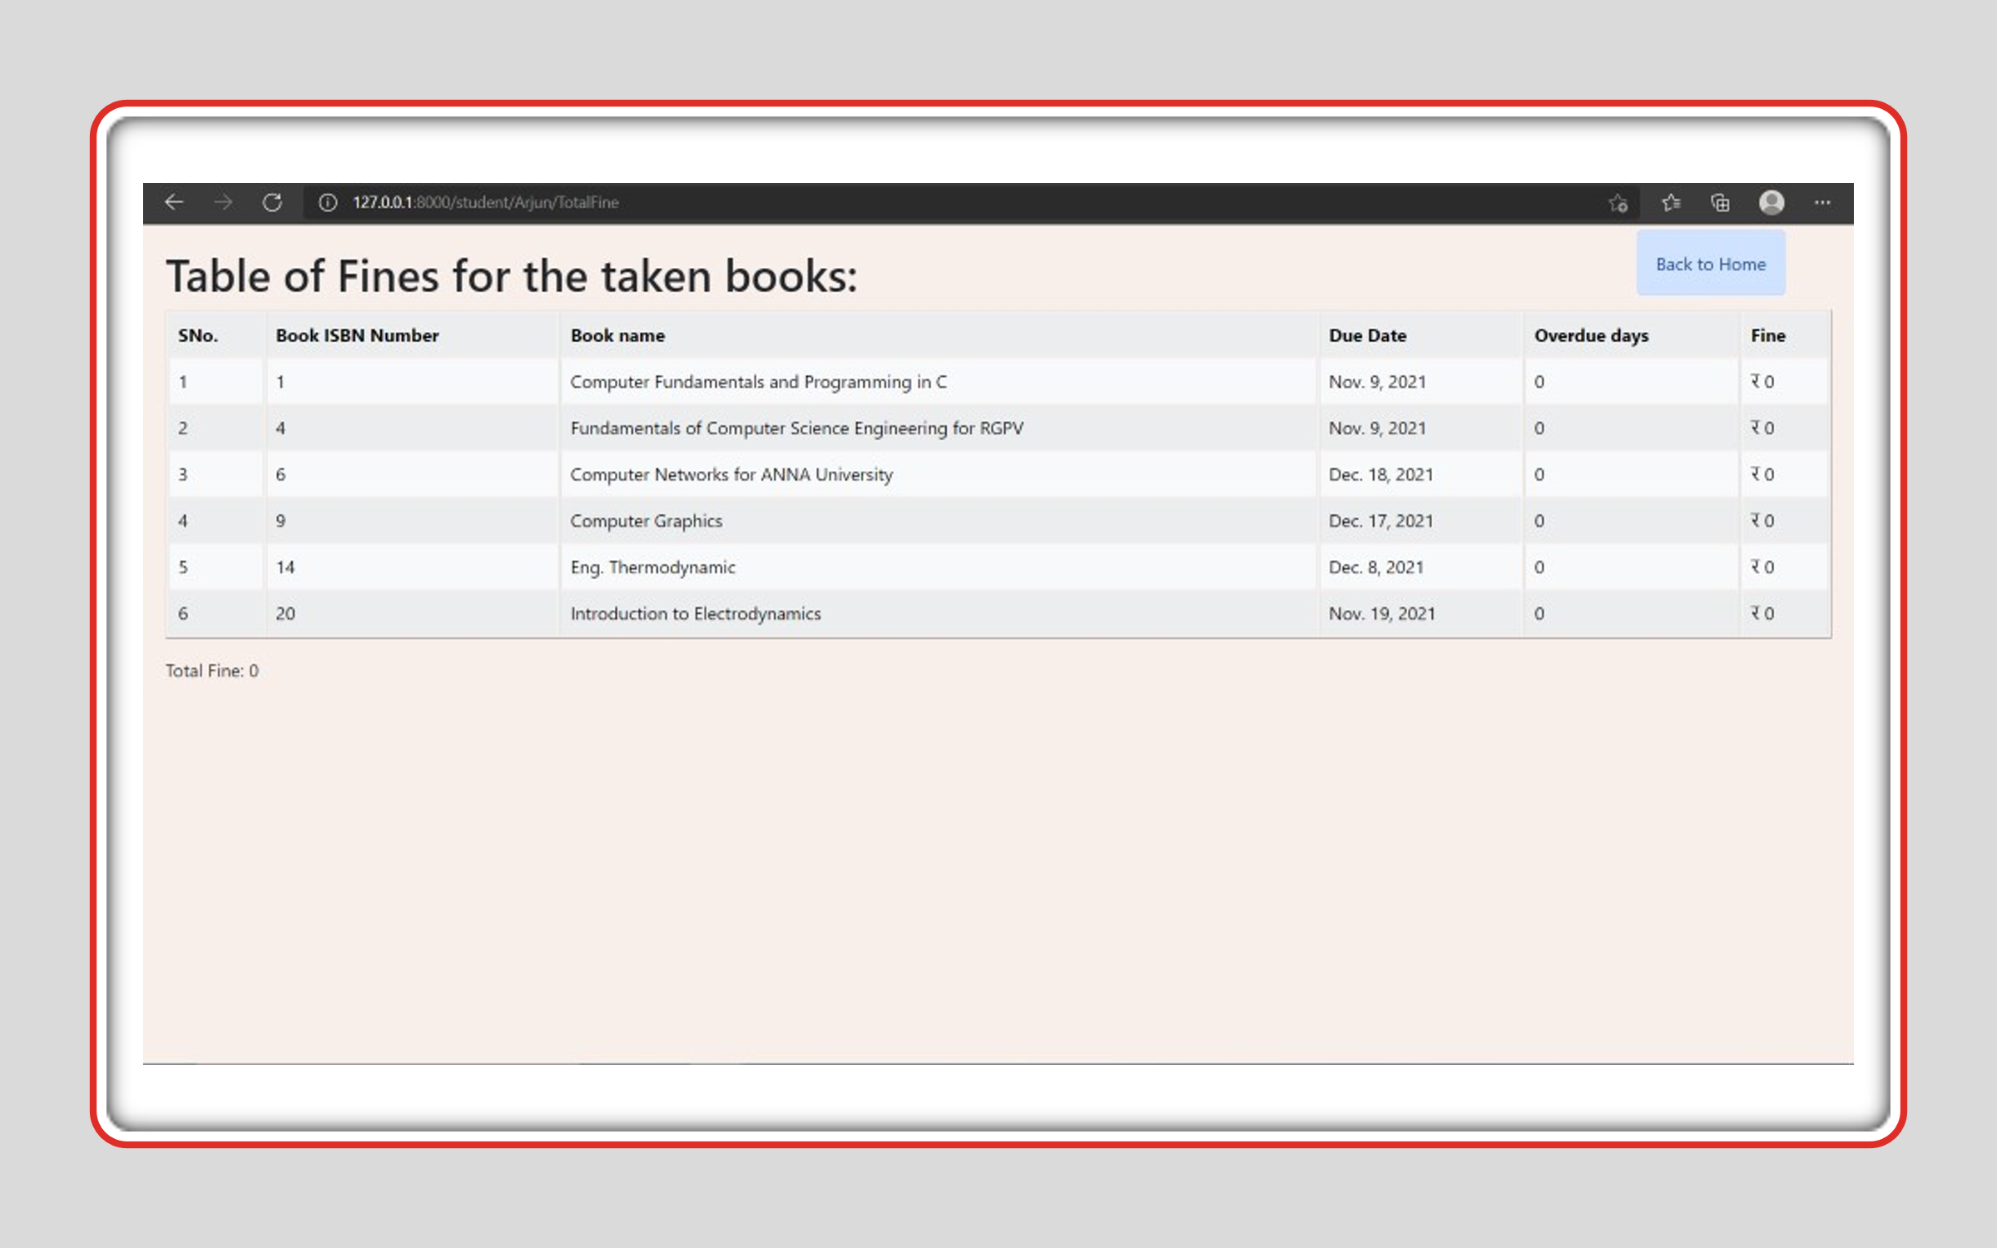

**Request for Extension**

Here an Extension option is provided for the list of Taken books which follow these conditions

Criteria:

1.Book is not Reserved

2.Book is not Overdue

If the above conditions are satisfied, then he can extend reservation of that book.

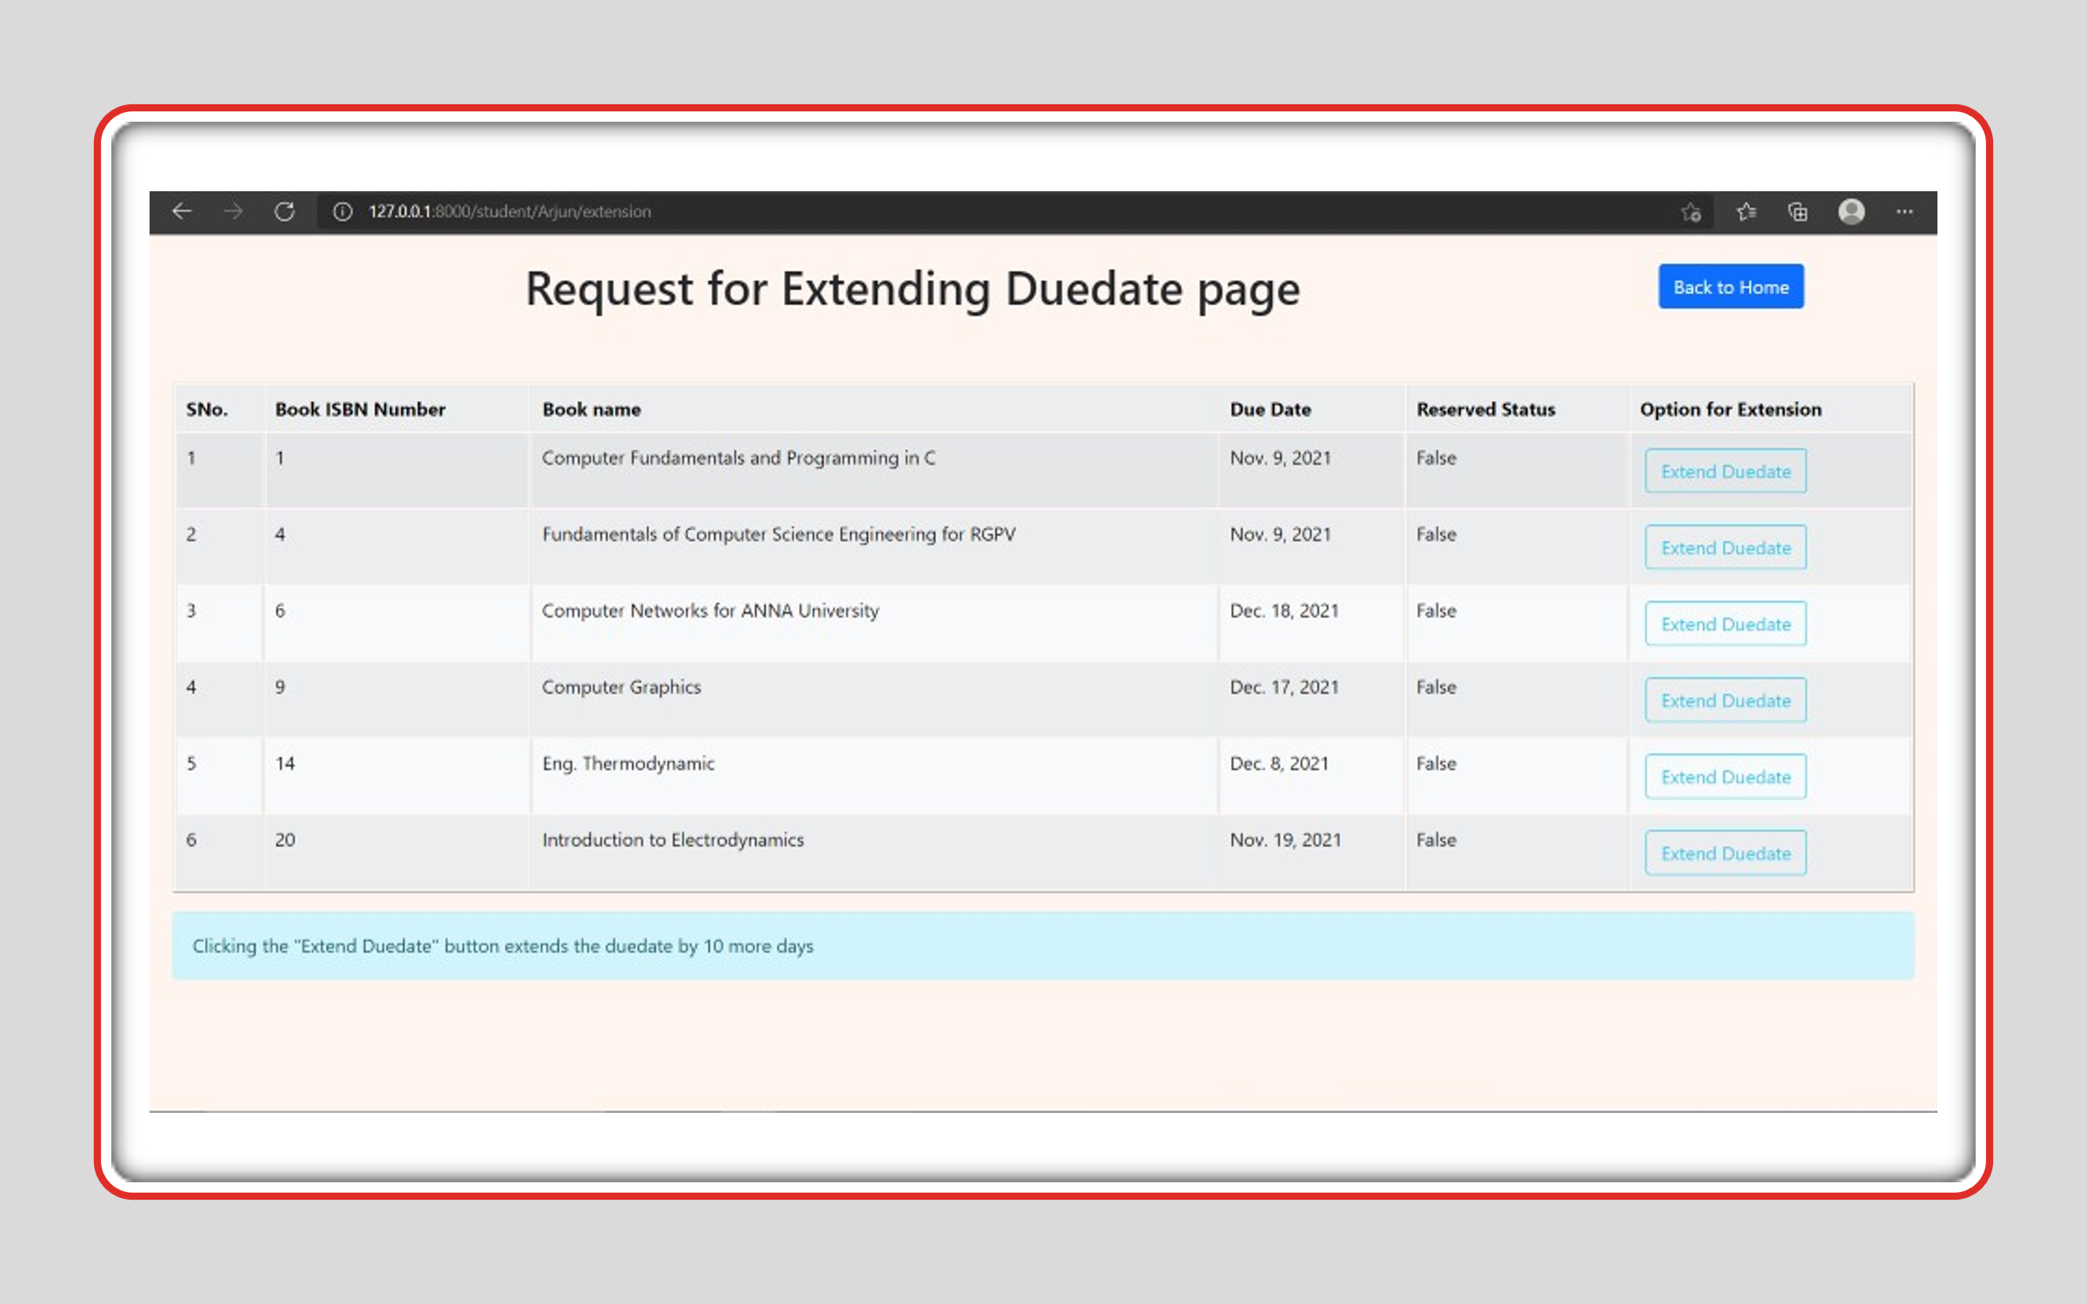

After student here comes our next member i.e., librarian.

**LIBRARIAN**

**Librarian login:**

Here librarian can login with his credentials. After login, he can see the following options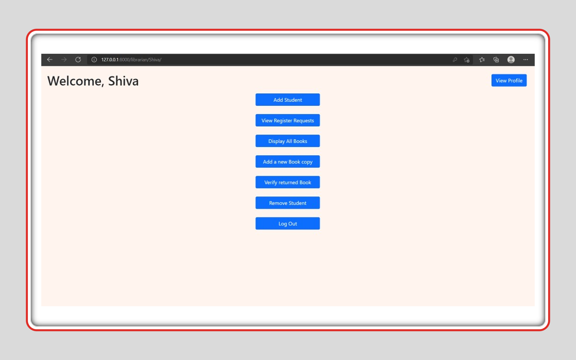

**View profile:**

Here the librarian can view his profile and, he can update his profile. In profile the following details are available:



Update profile also incorporates an option to change password if required.

**Add Student:**

Here the librarian can add the new student by filling the following details

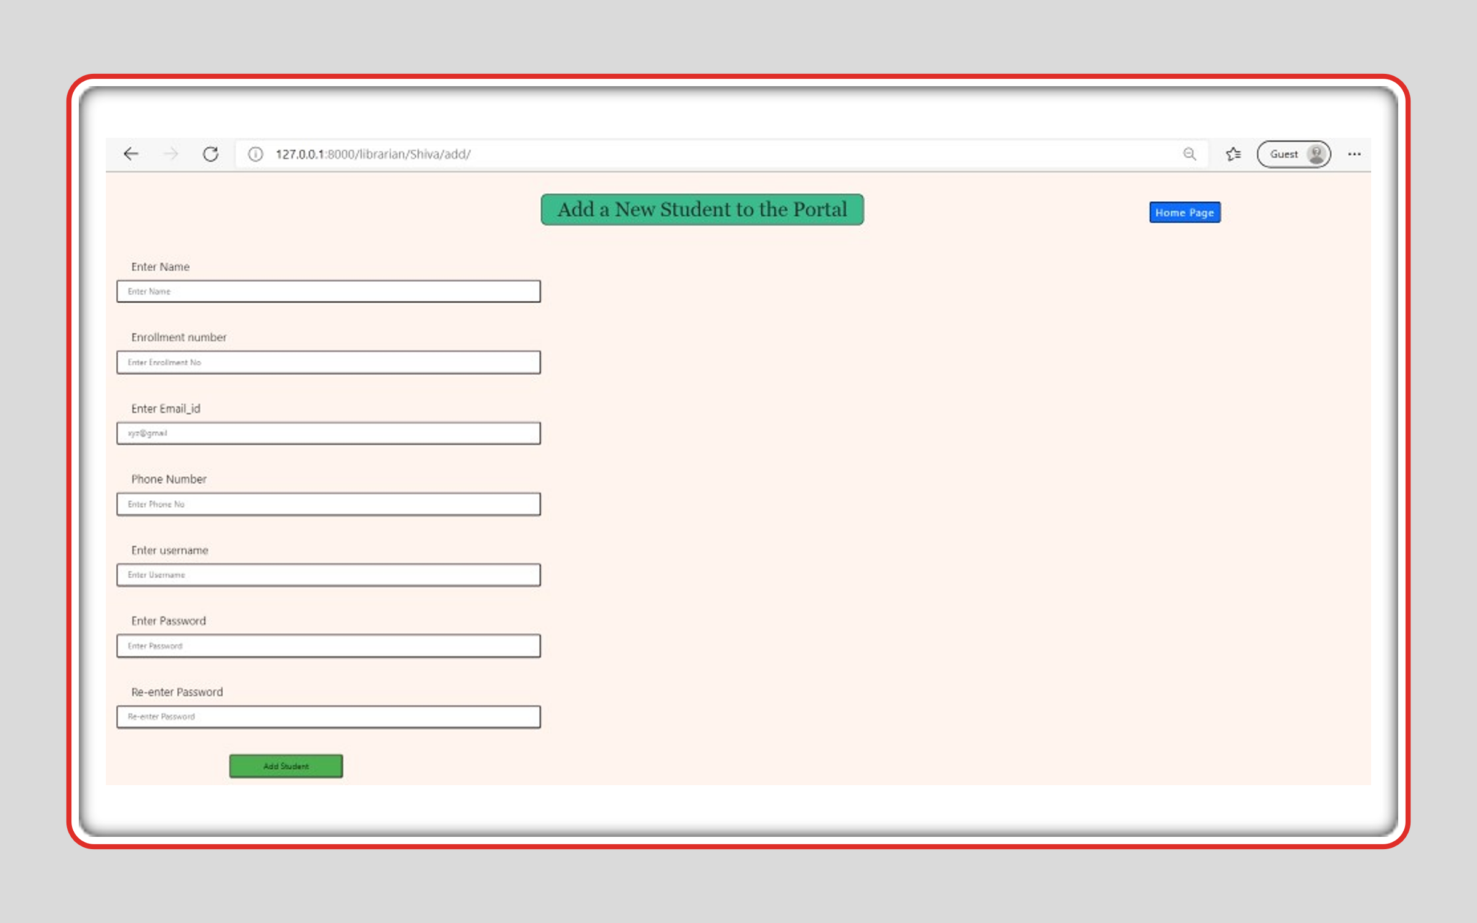

**View Register requests:**

Here the librarian can view the student who had sent the request. By clicking on the student’s name, he can view the form which had been filled by student in the request form, by verifying all details provided by the student librarian can accept the request and add the student or delete the Request.

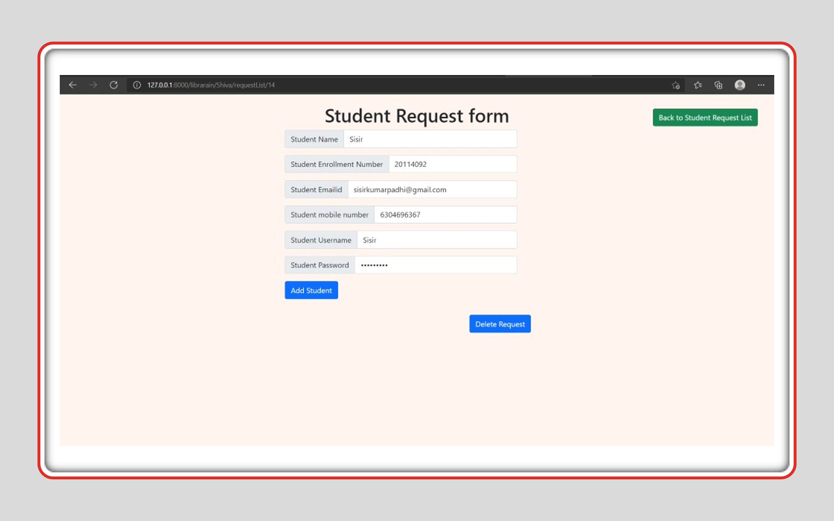

**Display all books**

Here we can see the list of books which are available in library. It also provides an option for librarian to delete the books based on the availability status of book. The list includes the following details:

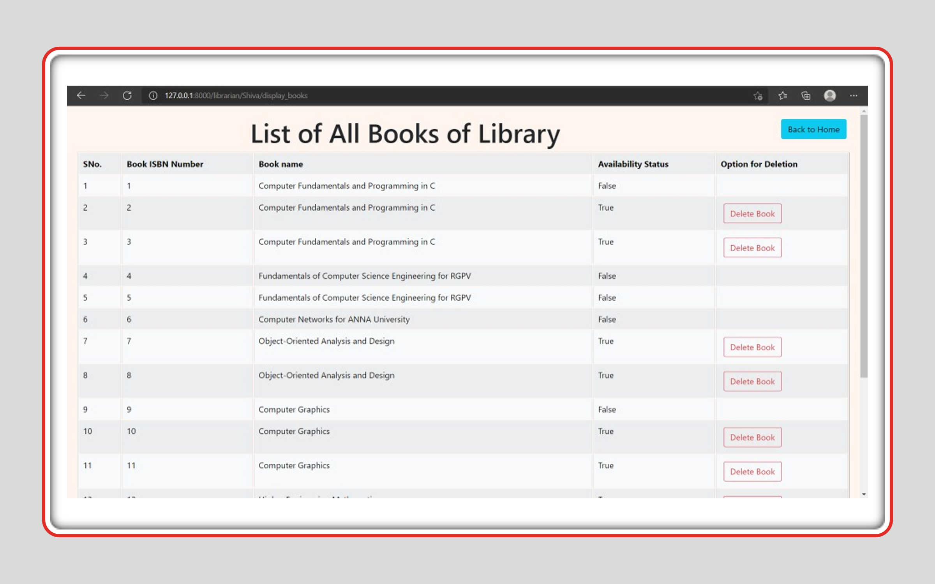

**Add a new Book copy**

Here librarian has following provisions

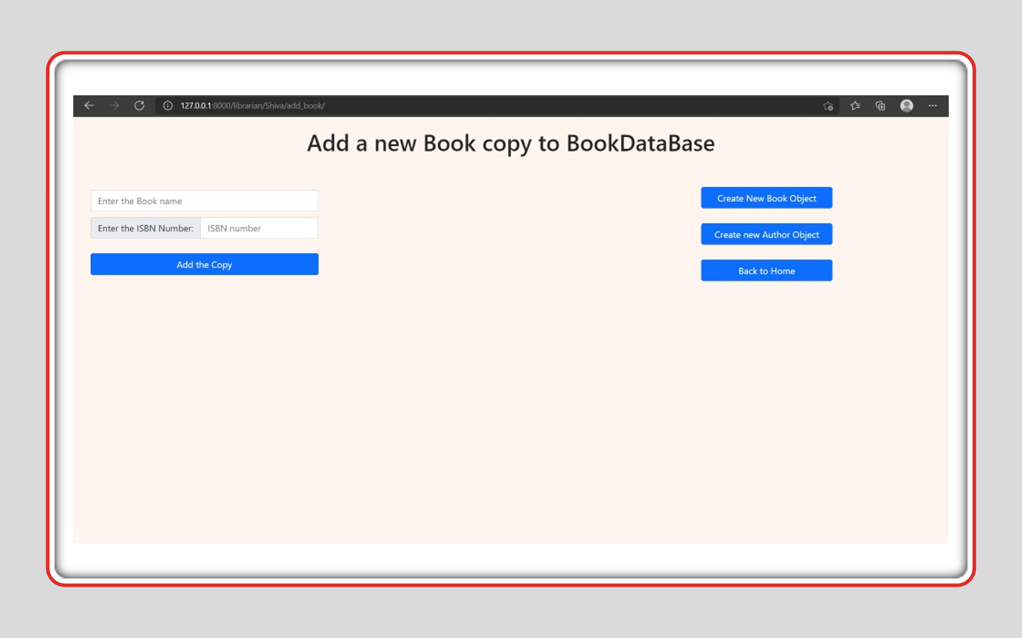

**Verify return book**

Once the book got returned by a student. The librarian verifies the details of book and make the book available to all the students if the book was not reserved by any other student.

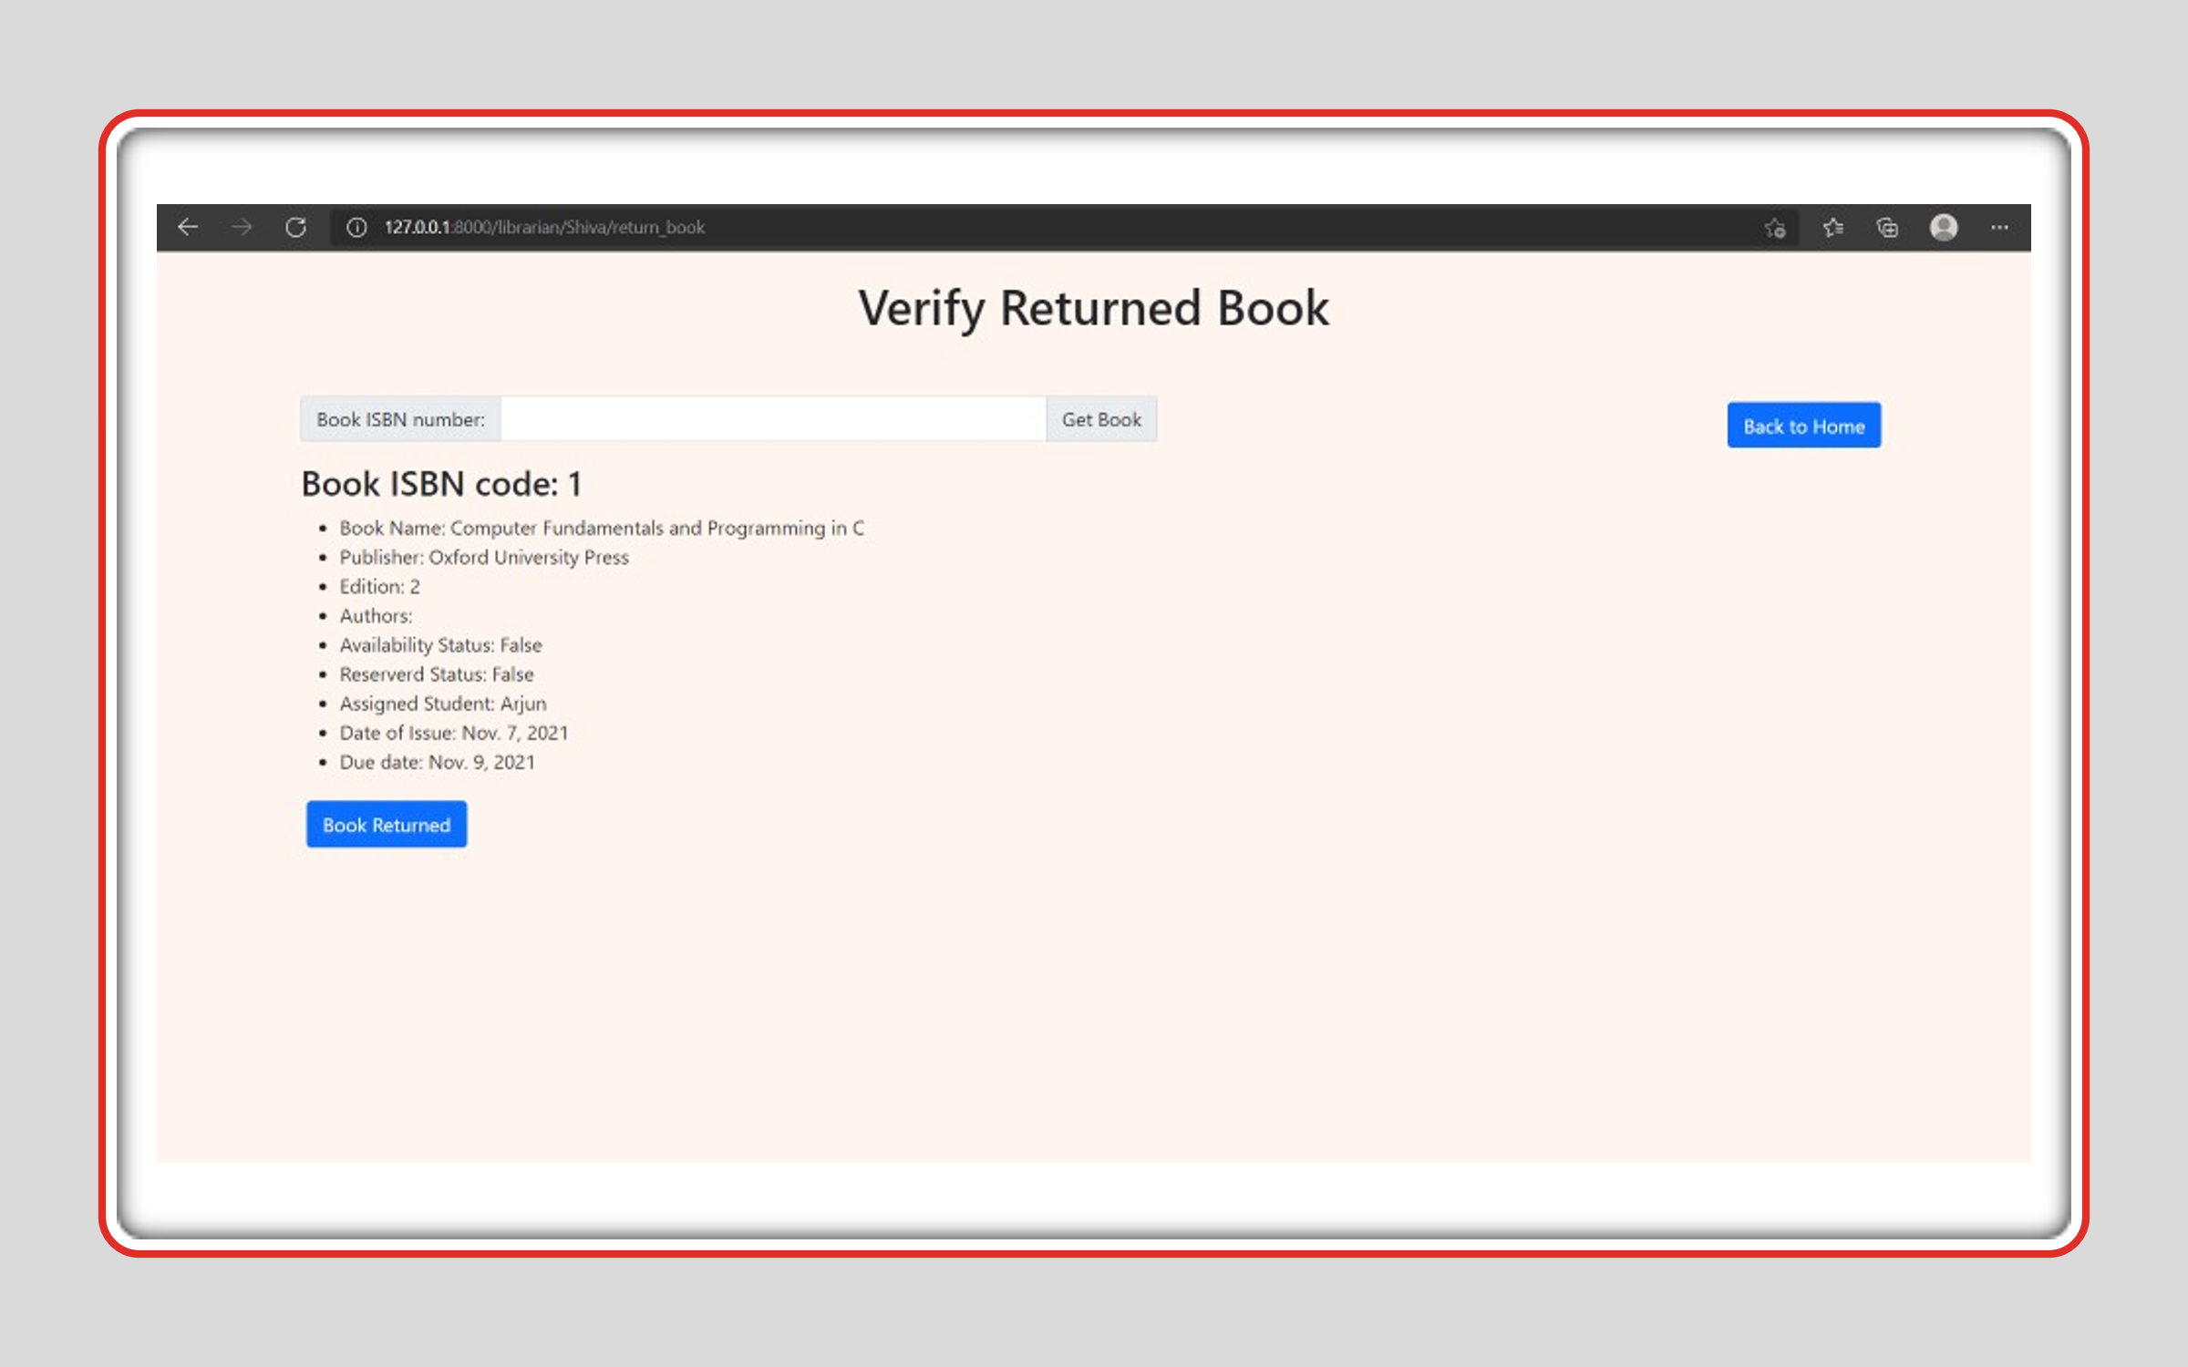

**Remove student**

Librarian can remove the student if required by filling up the student name and verifying the details of the student.

The Next option in the Main page is Administration Login. By entering Administration login, it takes us to Django Administration site where we can view and modify the databases, but it can only done by the administrator.

